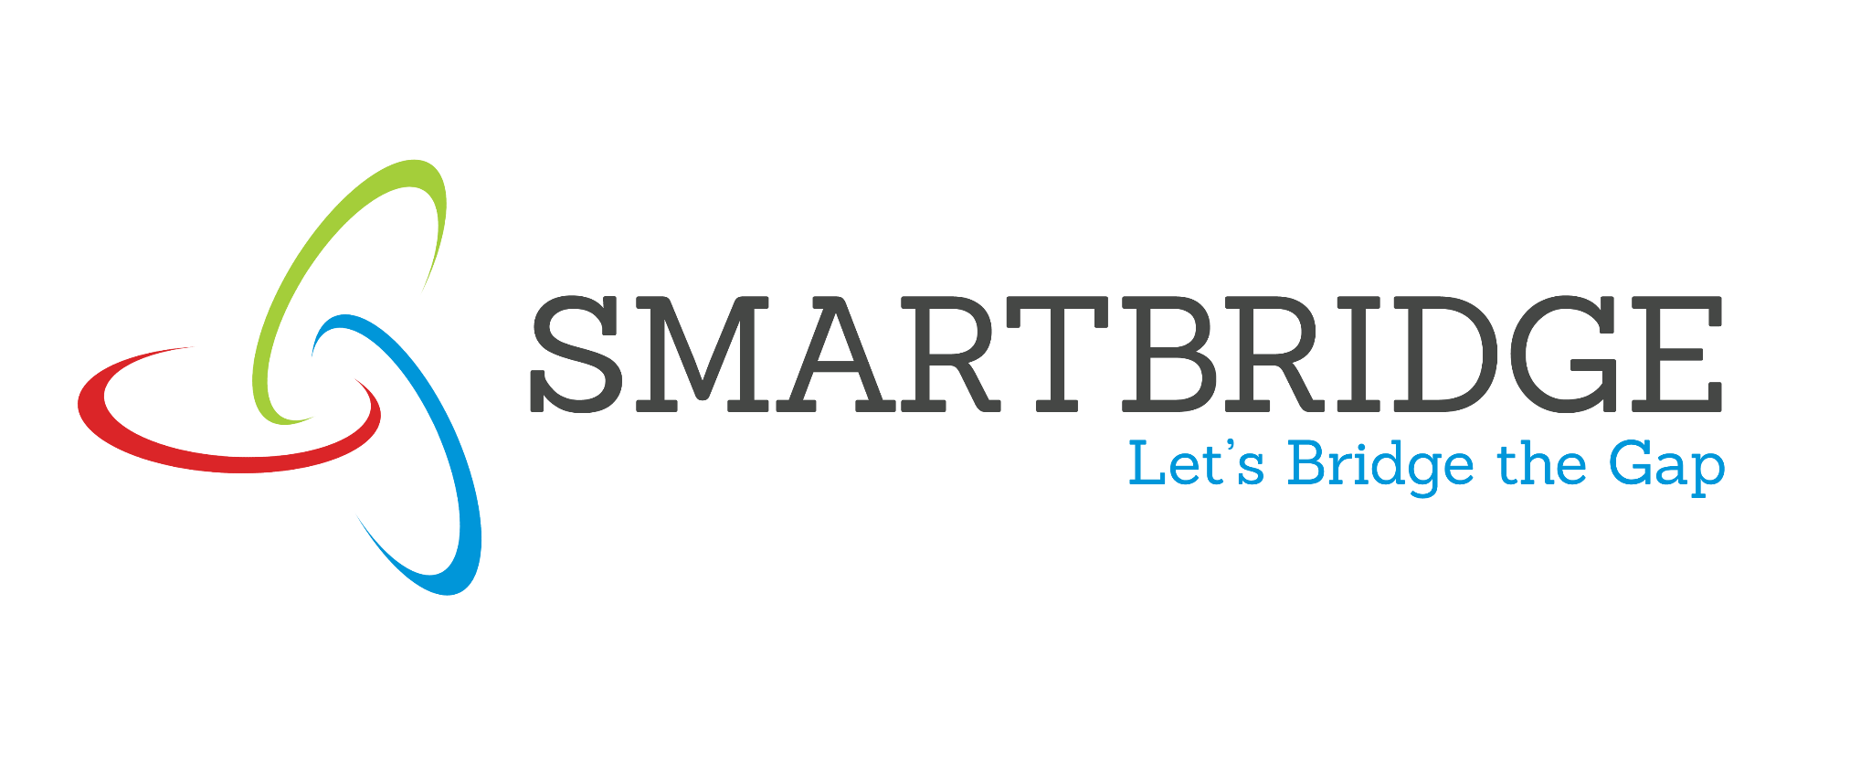

Empathy Map

Date | 3rd July 2026
Team ID | xxxxxx
Project Name | Rising Water
Maximum Marks | 4 Marks
Empathy Map

Create an empathy map to understand your customer/user from four perspectives - what they Say, Think, Do, and Feel - in relation to the problem your project addresses. This helps the team build a customer-centric solution.
- Floods cause major damage to lives and property.  - We need accurate flood warnings before disasters occur.  - A prediction system can help us prepare in advance. | SAYS |  | - Can flood risks be predicted accurately using weather data?  - Early warnings can reduce loss of life and property.  - The system should be simple and reliable for everyone | THINKS
PERSONA NAME
(Role / User
Type):Disaster Management Officer/local Resident
- Monitors rainfall and weather forecasts regularly.  - Takes preventive measures during heavy rainfall.  - Uses flood prediction results to plan emergency responses. | DOES |  | - Worried about sudden floods during the rainy season.  - Hopeful that technology can improve disaster preparedness.  - Confident when receiving timely and accurate flood alert | FEELS

